ChauffHer
Driven by women, for women
It in business lab
2024
ChauffHer
Driven by women, for women
Introduction
Today, millions of consumers prefer the constantly developing ride-hailing services to get around the urban area. Nonetheless, accessing these services poses a cardinal safe concern to women with several cases being reported to show the need for safer services.
ChauffHer fills this gap through a ride-hailing application specifically designed to be used by female passengers, where safety, trust, and, more importantly, women’s promotion is of immense concern. Developed only for the female riders and operated by the females, the ChauffHer will give these women the confidence to travel safely while empowering more women into employment as drivers or entrepreneurs. What is fascinating about this new offering is that it is so much more than freedom of movement, this is the new definition of safety and power in the ridesharing business.
Vision
To transform the concept of ride-hailing services and become the global leader in the sphere of women-only transportation services that will open an era of safety, trust and women’s empowerment. This is our goal, almost by default, through constant growth, venturing new business sectors, wherein staff members and stakeholders are valued and their trust respected.
Mission
To ensure the proposition is women-friendly, our goal is to create a ride-hailing platform that is secure, dependable and inclusive. ChauffHer is a means of providing employment to women drivers that will at the same time afford full confidence, conveniences and safety of every lady rider. This will be achieved by implementing employee training, applying new technologies, engaging partners that promote safety and access.

Our Services
ChauffHer is designed for comfort and convenience ensuring that it operates as an application or system as convenient as the InDrive or Yango.

•Fare Flexibility:
It gives passengers the ability to set their fare for a particular place a feature that empowers passengers. These offers are easily relatable to by drivers taking rides that are of their choice depending on their preferences. The app also offers a third-party fare for cyclists and car owners to use and reach a fair settlement given the current market trend.
•Diverse Ride Options:
ChauffHer has many services to meet consumers’ diverse traveling requirements and price criteria by offering a vast range of vehicles. Whether a person is in the market for cheap transport to and from nearby locations, a gathering transportation service, luxury transport where an individual can enjoy the extra comfort, or a sharing green transport that is a friendly way to travel then there is no reason to look further.
•Commitment to Safety:
Each aspect of the service ensures the protection of the ‘me too’ generation in the provision of the service through enhanced application security, and a rigorous driver screening protocol.

Rides
•Motorbike
For those, who are using the service to get from one place to another fast and without many stops, there is a motorbike that is fast, agile, and can be stated as affordable for most people. For those short trips through heavy traffic this is a great car to have to ensure that you get to your desired destination in the shortest time possible and with minimal usage of fuel.
•Auto Rickshaw
Auto rickshaw transport means for short distance transport within the city are economic and more feasible. By virtue of these features it means that they help people cover difficult pathways in congested pedestrian areas in a comfortable and efficient manner at the same time minimizing on costs.
•Mini Ride
The Mini Ride is suitable for passengers with a limited budget as the service provides almost everything that is needed for a short city trip and the car is clean. Suitable for one person or a few people, this option means a fast and problem-free trip as well as being economically beneficial.
•Standard Ride
The catering service of the Standard Ride has been creatively designed to offer a comfortable and reliable service the company has fitted all cars with air condition and offers a very smooth ride. These cars are serviceable for short trips or for hours on the stiff, and therefore suitable for every individual trip.
•Premium Ride
For the maximum level of comfort try our Premium Ride service. Specially designed for people who want nothing more than professional care and only the best services, this option provides premium level. It has large surface area and elegant services meant to make those special occasions or longer trips as comfortable as is possible.
Key Features
User Features
•All-Women Drivers: All the drivers that are working for the platform are female, which makes the ride safe and comfortable for ladies.
•Real-Time Tracking: GPS tracking for everyone, both for riders and their kin to ensure, the comfort and safety of the trip in real time.
•Emergency Button: The direct access to the local administration or other tom contact in case of emergencies before the design of such contacts.
Driver Features
•Training Programs: Food safety, hygiene etiquette and customer relations training to guarantee quality services.
•Flexible Hours: Independent contractors are free to choose the hours and days they want to drive and hence there is flexibility with working hours.
•Earnings Insights: Definite and understandable splits of daily/weekly/grand totals including bonuses and tips where drivers can quickly observe the sum they received.
•Safety Features: A distress button to be provided for drivers to use in reporting any form of danger making traveling more secure for them.
Safety Measures
•Verified Profiles: Strict driver and rider screening process to provide credibility and security for everyone.
•Ride Monitoring: Automated systems observe the trips to flag any form of suspicion or any duration of a stop to avoid any attacks on the drivers or the riders.
•Check-In System: Alerts to the emergency contacts at the time of beginning and ending the trip to also let the family members know.
•Gender-Specific Support Team: A platform for female riders with a separate support team to address their issues and questions in a very professional and with the necessary care.
All these features and measures work conjointly to offer safety, flexibility and an autonomous control for both users and driver.

Market Overview & Industry Landscape
The ride-hailing industry in Pakistan has grown very fast due to a surge in demand for faster, cheaper and efficient means of transportation. Private chaffeurs and taxis have been replaced by efficient, easy to access and fully operational applications such as Uber and Careem. However, the sector grows on, local players and small specific service providers have cropped up to fill demand services in the market.
ChauffHer seeks to benefit from a market that has not yet been penetrated fully by any taxi hailing service, in that it majors in ferrying female passengers only. Given the increasing concerns with the safety of passengers especially the females the need for gender targeted services that is trusted is ever increasing. Some of the major cities in the market of ChauffHer are Faisalabad, Quetta, Islamabad, Lahore, Karachi, and Peshawar all of which have their own requirements of transportation.

Key Industry Trends
1.Safety Concerns:
Currently in Pakistan, safety is a major concern and a concern of much debate especially for female users of ride hailing apps. Several high-profile cases have further demanded improved forms of transportation security hence increasing demand for the female-only ride-hailing apps that would provide safe means of transport for ladies.
2.Women-Only Services:
Such an upward trend in the provision of women-only ride hailing services is fueled by the fact that as the society becomes more safety conscious, women prefer to be transported by driver only female ones. The general audience is shifting to those services that can guarantee more security to women enabling them to travel without any restrictions.
3.Sustainability:
Policies and measures accompanying the trends in intensification of the environmental awareness of consumers create higher demand for environmentally friendly transportation services. The opportunities in the market include the use of electricity powered vehicles, car sharing and other corporate conservation measures.
4.Rural-to-Urban Shift:
While there is pressure on the growth of new markets in ride-hailing services, they are not being limited to large cities alone due to advancing urbanization. Lahore, Karachi and Islamabad are growing fast however, there is a rising need for efficient mobility services in rural and tier two cities.
Growth Potential
1.Expanding Reach:
Hence, the current and future growth strategy of ChauffHer is to target the Unserved/Uncrowded Markets, specifically, cities and rural regions which lack a safe option for women transportation. This may more than triple the current market reach and might also be able afford to offer services to all those women who may require safe mode of transport.
2.Global Expansion:
The global scope also presents a strong possibility for further growth of ChauffHer’s women only service concept in other markets with similar needs in the future given rising concerns over the safety of women and the emerging associated needs for gender specific services in other parts of the world.
3.Empowering Women:
With training programs that cover professional and personal development, and diverse employment options ChauffHer aims to help women become drivers. It helps the women stand up on their own and perform earning activities simultaneously makes them independent and plays a big part in economic processes.
4.Sustainability Initiatives:
To make ChauffHer even more attractive there are options such as carpooling services and EV cars that will significantly decrease operational expenses while making a move towards environmental conservation. It ties in with increasing customer awareness of their need for sustainability–centric corporate behavior.
5.Government Collaboration:
It’s also true that the government can offer the funds, insurance, and policy that ChauffHer requires to remain a secure and cheap service. All these partnerships will create sustainable and positive relationships because they are bound to have positive regulations and safety requirements.
6.Technological Advancements:
To remain competitive, ChauffHer will maintain investing in new technologies that will be incorporated into the app and some of the app features that are still to be included are Women Driver Training Portal, an application with multilingual support, and the most important, the ChauffHer preferred driver matching system. These enhancements would have the effect of helping to address the needs of multiple customers and at the same time facilitate safe, efficient and secure rides.

Customer Profile: Target Customer Characteristics
1. Primary Audience:
• Women aged 18-50
o Demographics: Single young employees, students, housewives, and organizations and individuals traveling on business.
- Needs: Also, women who often consider safety, comfort and cost of their daily transport.
2. Key Characteristics:
•Safety-Conscious: Stresses one self’s security and looks for safe, safe means of transport.
•Tech-Savvy: Proficient with wearing, use of Smartphones /mobile apps, e-payments, applications and other related technological solutions.
•Budget-Aware: Wants to pay less, but still has nice and steady means of transport.
3. Behavioral Traits:
- Frequent Travelers: Uses transportation within one week for work, education, other errands, or for business travel.
- Preference for Female Drivers: Appreciates the first, second, and third degrees of trust and comfort that comes with having female drivers only.
- Environmentally Conscious: Cares about the environment and appreciates it when firms go green.
- Empowerment-Oriented: Maybe incline to support those companies that help women gain power and equality.
4. Secondary Audience:
- Mothers with Young Children: Looking for safe and reliable means of transport that will provide comfort and safety insecurities.
- Women from Rural Areas/Smaller Cities: Female residents in communities where they cannot easily access safe public transport or need alternative affordable ride hailing services.

Market Segmentation and Targeting

Market Segmentation:
1. Working Women (25-45 years):
- Needs: Daily travel to and from work and other responsibilities as well as transportation within one’s means of business.
- Characteristics: For better understanding, professional means that the employees’ principle is to follow the contract agreement to a letter and has ordered timely; time-conscious means that employees stick to their schedules and never extend their hours of working while safety-conscious means that employees complete data entry without exposing themselves to high risk. Would like the least amount of waiting time possible.
- Challenges: Based on the triple constraints of time, scope, and cost.

2. Students (18-24 years):
  - Needs: Being affordable, convenient and quite easy to access, it serves best purposes of school, universities or part time employment.
  - Characteristics: Difference in as being Lean, Technophile and Connected. Probably to utilize for small and nearby trips.
  - Challenges: The consumers’ concern about the cost of travel and the necessity of matching their travel plans with their schedules.
3. Mothers/Homemakers (30-50 years):
- Needs: Comfortable and secure drives for general family chores, children’s school drop offs and pickups and other activities in the day.
- Characteristics: Family oriented, aseptic and prefers comfort. Probable to use the service for actualizing the various activities within the day.
- Challenges: The pursue of child safety, comfort, and convenient access.
4. Travelers/Businesswomen (25-50 years):
- Needs: Luxury, timely and en-suite transport solutions for commercial, airport-portal and touring and other types of business and recreation.
- Characteristics: Specifically, first time business and leisure travelers who are more conscious with concerns to quality Services, Politeness and Punctuality.
- Challenges: Scheduling, which entails a necessity to provide reliable and qualitatively high level of service in business and everyday life.
Market Targeting:

1. Working Women (25-45 years):
- Strategies:
- Advertising through digital platforms such as LinkedIn, Instagram and face book.
- Sponsored content and partnership on the professional network.
- Service customization for working professionals (e.g., app features such as pre-booking for a ride, or or more premium services).
2. Students (18-24 years):
- Strategies:
- Identification of universities and student organizations to engage in campus relations.
- Student discount, membership, and occasional special deals on social networks.
- Instagram promotions student endorsers and university activities to reach out to young users keen in technology.
3. Mothers/Homemakers (30-50 years):
- Strategies:
- Consumer targeting using community outreach programs that will favor families.
- Special offers and coupons for mother and housewives, especially during school-going terms and other family choral activities.
- Promotions with parenting blogs and celebrities that relate to issues such as safety and easy to handle products.
4. Travelers/Businesswomen (25-50 years):
- Strategies:
- Express business-oriented services with focus on schedules and comfort for business and tourists.
- Special transportation services and travel or flying point rewards for repeat customers.
- Partnership with corporate businesses to supply appropriate ride services that fit employees.

SWOT Analysis
Strengths:
- Niche, Women-Only Service: ChauffHer provides a unique, women-only platform that prioritizes safety, trust, and comfort, addressing a significant gap in the market.
- Empowering Female Drivers: The service offers empowerment opportunities for women, enabling them to work flexibly and earn independently, fostering economic inclusion.
- Advanced Technology: Innovative features like fare negotiation, real-time tracking, secure payment systems, and the ability for drivers and passengers to set preferences enhance the user experience and satisfaction.
- Strong Brand Identity: Positioned as a safe, reliable, and empowering option, ChauffHer resonates deeply with women looking for a secure ride-hailing solution.
Weaknesses:
- Limited Market Reach:
At present is active only in a handful of cities which hinders its prospects in other areas of Pakistan and abroad.
- High Operational Costs:
High funding is needed for training of drivers, safety protocols, and ensuring credible and safe marketplace.
- Cultural Resistance:
There is the problem of acceptability since resistance can be expected in conservative markets where women-only services are regarded as strange.
- Brand Awareness:
Establishing goodwill and trust, especially when entering the market as a relatively younger company providing financial services is still to this organization a work in progress in a fiercely contested industry.

Opportunities:
- Government Partnerships:
Possible partnership with governmental organizations in terms of financing, legislation safety advocacy and assistance in compliance with legal requirements which will add to companies’ reliability and credibility.
- Expansion of Female Employment:
Since ChauffHer creates more opportunities for female drivers to work, it can help all the sectors where women might need a source of income to be financially independent.
- Rising Demand for Women-Only Transport:
There is a growing awareness of safety in society and particularly for women; making ChauffHer a service that targets a huge and an ever-growing market.
- Sustainability Initiatives:
The addition of environmentally sensitive strategies such as having pure electric cars or pool services could increase environmentally savvy customers while proving cost effective.
- Geographic Expansion:
By penetrating such regions, it achieved good growth and venturing into other areas such as the rural areas and other countries that have similar needs of women being provided with transport as that of men would also lead to very good growth.

Threats:
- Intense Competition:
There’s high risk due to the existence of competitors as Uber and Careem to name a few, coupled with the fact that they offer multiple services. Still, new entrants from the local market could exacerbate the rivalry more.
- Regulatory and Compliance Risks:
Keeping up with looming legal issues and different taxes concerning operating a ride-hailing service continues to be a challenge since these rules are constantly changing.
- Economic Factors:
Political factors such as economic conditions, inflation and uncertainty, fuel prices may affect company profitability, pricing policies and Consumer demand.
- Cultural Barriers:
Some cultures, there may be cultural barriers in accepting woman-only services that limit market success and expansion.

Porter’s Five Forces Analysis
1. Threat of New Entrants
- Moderate to High: To play a role in the ride-hailing industry a company must make a large investment to acquire and maintain assets, technology and knowledge. Nevertheless, movements like the request for women-only ride-hailing services create a new demand that can be considered as an opportunity; unfamiliar players may be interested in entering the market for certain segments and regions.
2. Bargaining Power of Suppliers
- Moderate: In this case, the primary suppliers are the female drivers through who main service delivery takes place. Female drivers are still limited in terms of skills and rate a medium level of power due to the availability of skilled women drivers being scarce in many regions. When the demand for women-only transport increases, the supply and demand functions are likely to change progressively.
3. Bargaining Power of Buyers
- High: Due to abundant competition in the market, the customer bargaining power is high; they have a choice of approximately equal standard transportation means, namely traditional taxis, rides hailing applications such as Uber and Careem, and other new mobility solutions. Due to the low switching costs involved and possible customer lock-in, services have been shifting constantly from one platform to the other depending on price, better service and convenience.
4. Threat of Substitutes
- Moderate: However, ride-hailing services offer a premium level of convenience, competitors such as established taxis, public transport, traditional carpooling and bike-sharing services present rather serious substitutes. These alternatives, although not necessarily as safe or nearly as convenient, are sometimes cheaper or easier to obtain, especially in large metropolitan areas.
5. Industry Rivalry
- High: The nature of competition in Pakistan ride hailing industry is cutthroat that is why big players are already residing in this sector such as Uber and careem etc. These competitors constantly seek to enhance how they deliver their value proposition through elements, including prices, availability and distribution, driver attraction, and customer satisfaction. Local professionals may continue the competition towards its intensification offering adapted services trying to compete on price or with focuses on services for woman only.

Sales and Marketing Strategy
Following are the marketing strategies we have, and aim to imply further:
- Digital Campaigns
  - To Promote the service by placing adverts on Social Media platforms such as Instagram, Facebook, LinkedIn, Association of the service with safety, convenience, and power. Partnering with Pakistani influencers and opinion leaders in a bid to further brand awareness especially those causing awareness on women issues, safety, and empowerment in the said country.
- Referral & Loyalty Programs
Coming up with a loyalty reward system that involves current customers providing other customers to make a purchase. Include incentives for the rider so that you can get more people who will be loyal to your service and use these services frequently. This strategy will go a long way in ensuring that the company’ s customers stick around and recruit other people to patronize the products.
- Community Engagement
Developing a relationship with schools, employers and other non-governmental organizations and offering a seminar, assembly, or workshop that will raise awareness on the rights of women to move around and be safe. Our goal is to involve ourselves in various outreach efforts within the community by partnering with other organizations to popularize the use of the women only services ride hailing.
- Localized Promotions
  - The flyer and posters should be used in marked areas such as malls, universities, and popular working and shopping centers. Making use of regional festivals and events, culture and holiday events with the aim of making localized advertisements and gaining more attention.
- Feature Highlights
  - Build awareness to end-users on new and unique app features that ChauffHer offers and has not been offered by other app, for instance the fare negotiating system, preferred driver, and tracking real-time of the car’s movement including tracking the passenger’s ride by her family members. Emphasizing such characteristics in tutorials, demo videos and using the actual users’ experience, explaining how these features contribute to safety, trust, and convenience.

Management Structure
- Zahid Abid
- Role: Chief Technology Officer
- Email: zahid@chauffher.com
- Meerub Nadeem
- Role: Chief Operating Officer
- Email: meerub@chauffher.com
- Zain Ali
- Role: Chief Financial Officer
- Email: zain@chauffher.com
- Affaf Kashif
- Role: Chief Information Officer
- Email: affaf@chauffher.com

- Hadia InayatUllah
- Role: Marketing Director
- Email: hadiyaint@chauffher.com

- Umer Zahid
- Role: Managing Director
- Email: umer@chauffher.com

Business Branding Materials


Logo

Business Cards
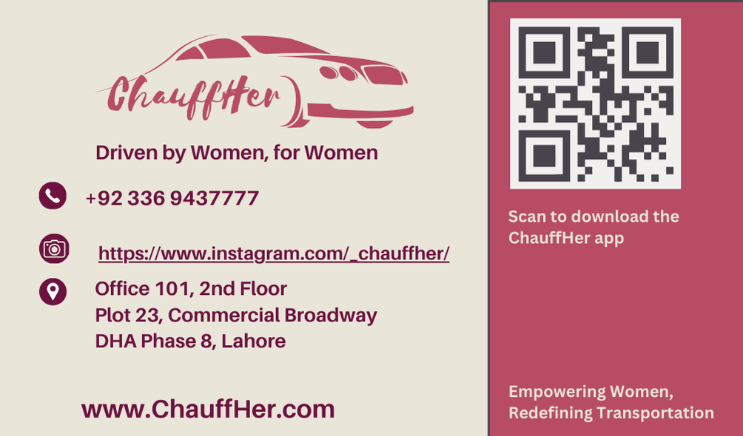

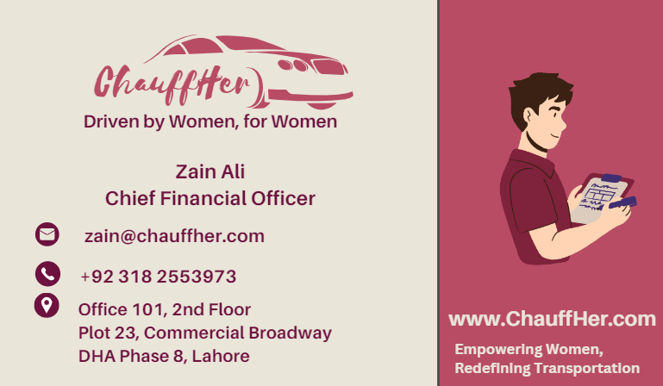
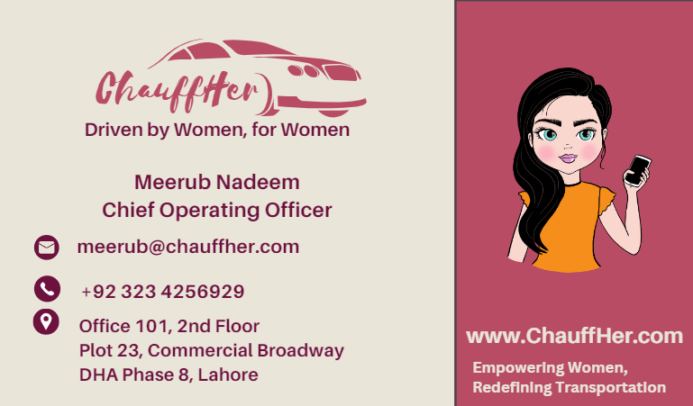
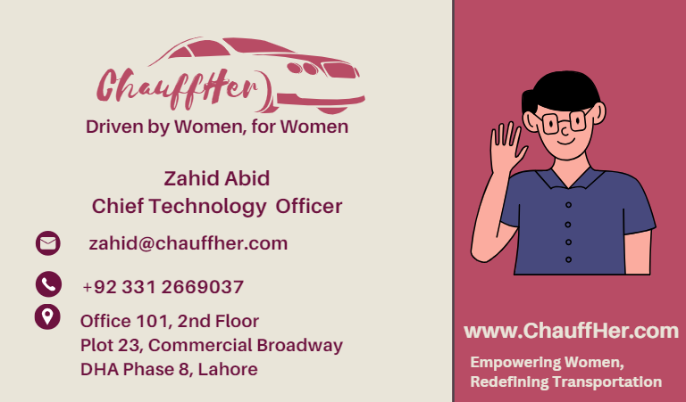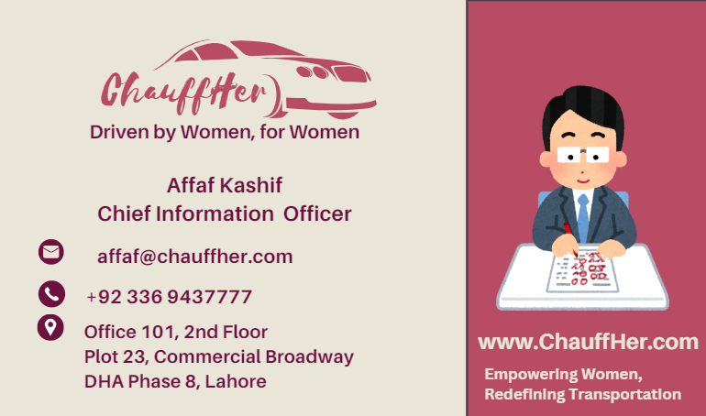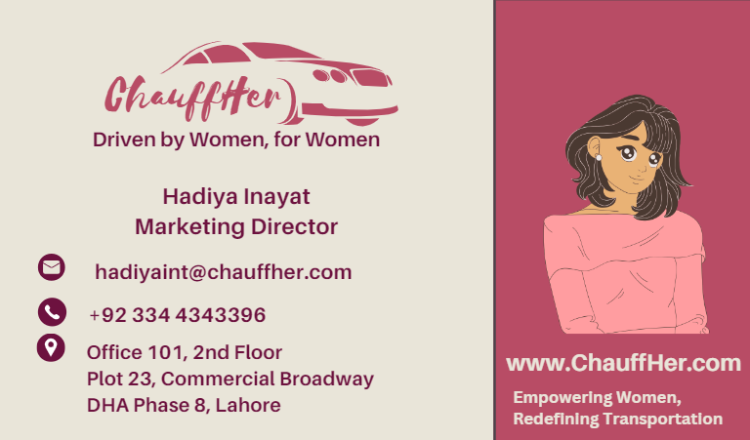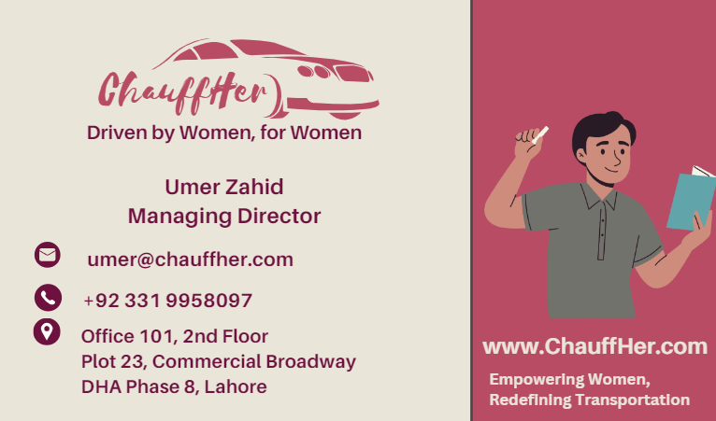

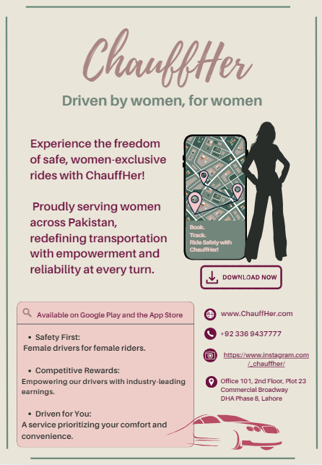
Flyer

Newsletter
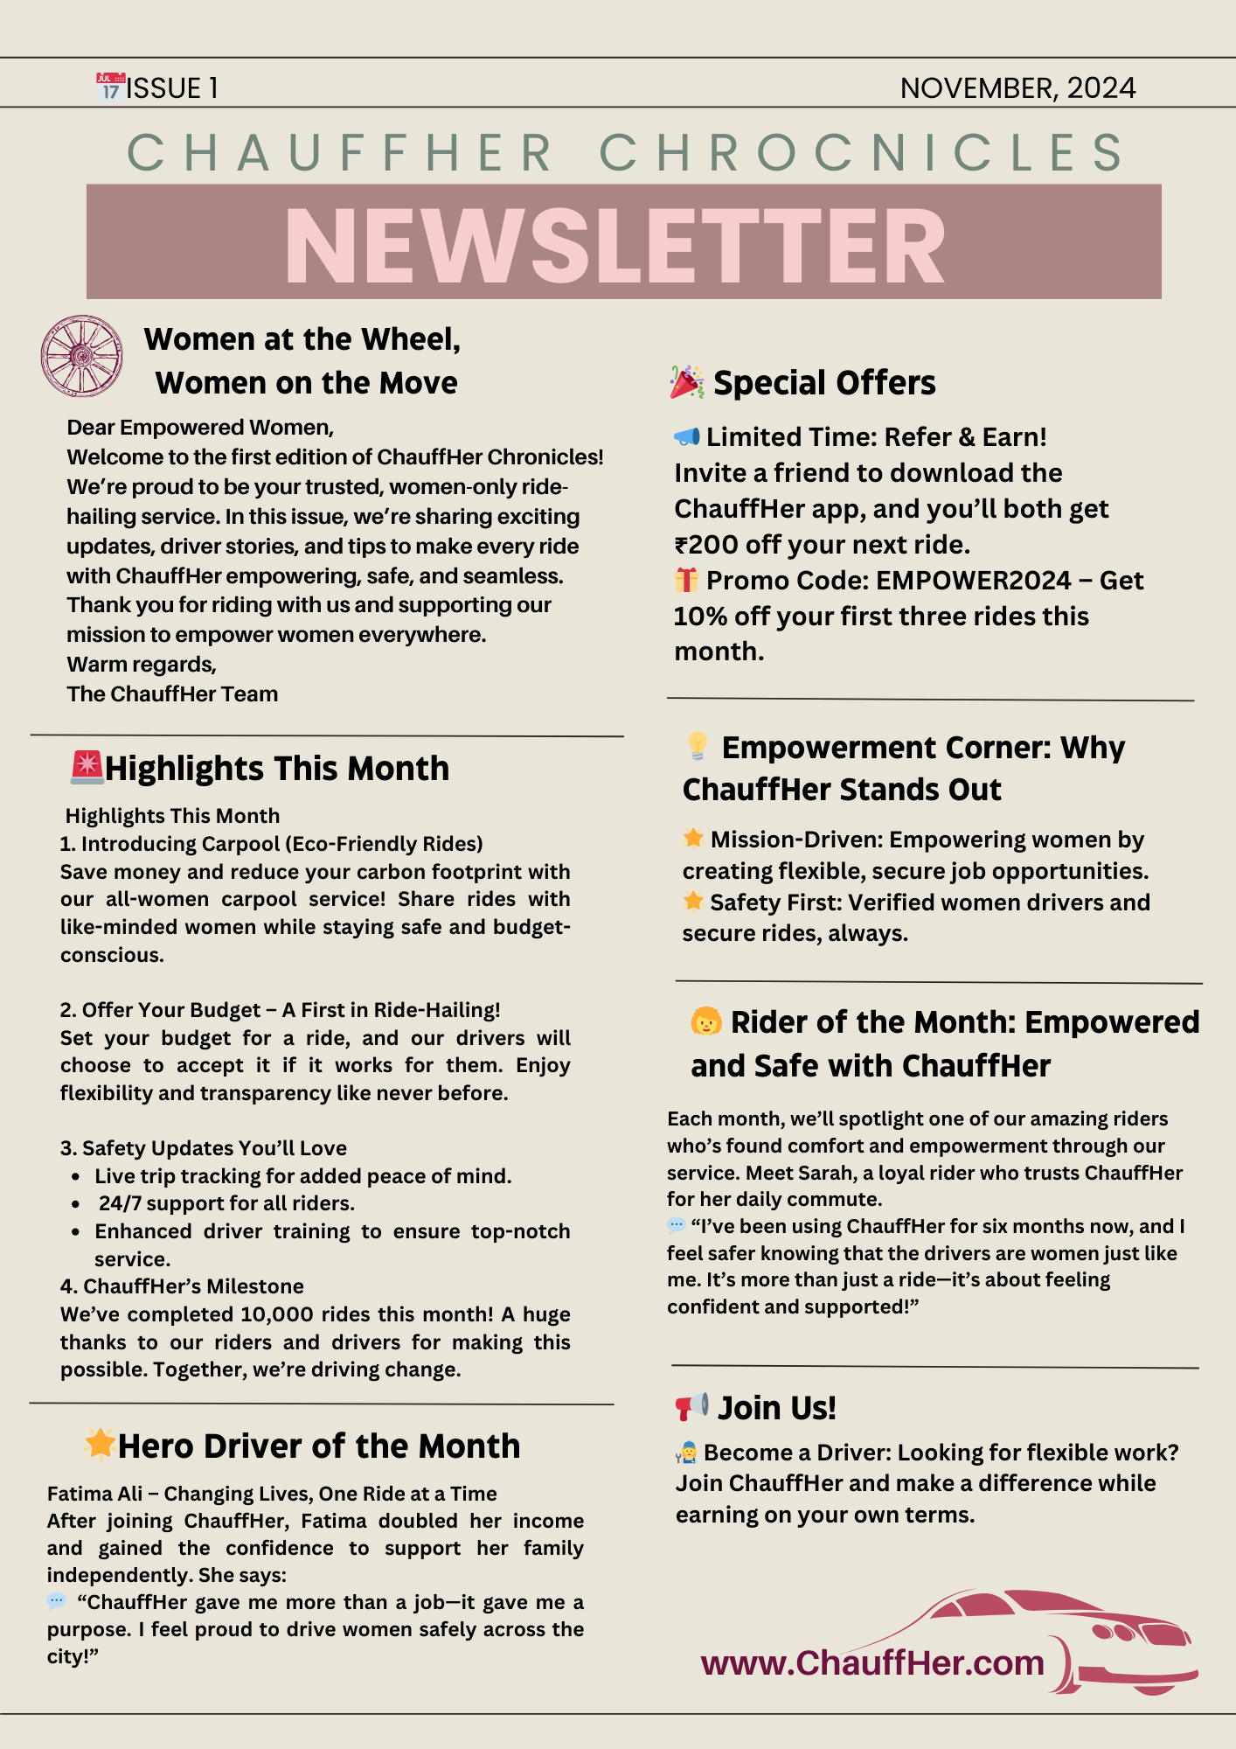

ALL LINKS:
Website: https://l245518.wixsite.com/chauffher

LinkedIn: https://www.linkedin.com/company/chauffherr/about/?viewAsMember=true

Instagram: https://www.instagram.com/_chauffher/

Facebook: https://www.facebook.com/profile.php?id=61569293715709&mibextid=LQQJ4d&rdid=QY8NN9yhLpard8gA&share_url=https%3A%2F%2Fwww.facebook.com%2Fshare%2F15XF8F7krv%2F%3Fmibextid%3DLQQJ4d

Meerub Nadeem 24L-5741
Zahid Abid 24L-5518
Zain Ali 24L-5618
Hadiya InayatUllah 24L-5559
Affaf Kashif 24L-5508
Umer Zahid 24L-5647
BFT - B

